**H2O Web Flow:**

Step 1: Import file(s). In this example, we have taken airlines data to predict the flight delays. Recommendation engines can forewarn flyers of possible delays and rank flight options accordingly.

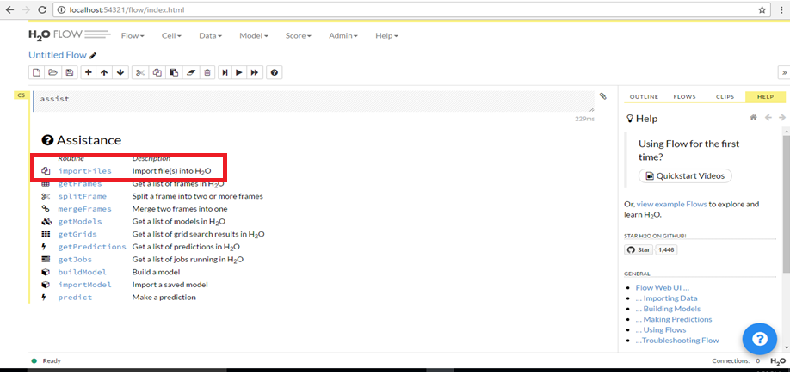

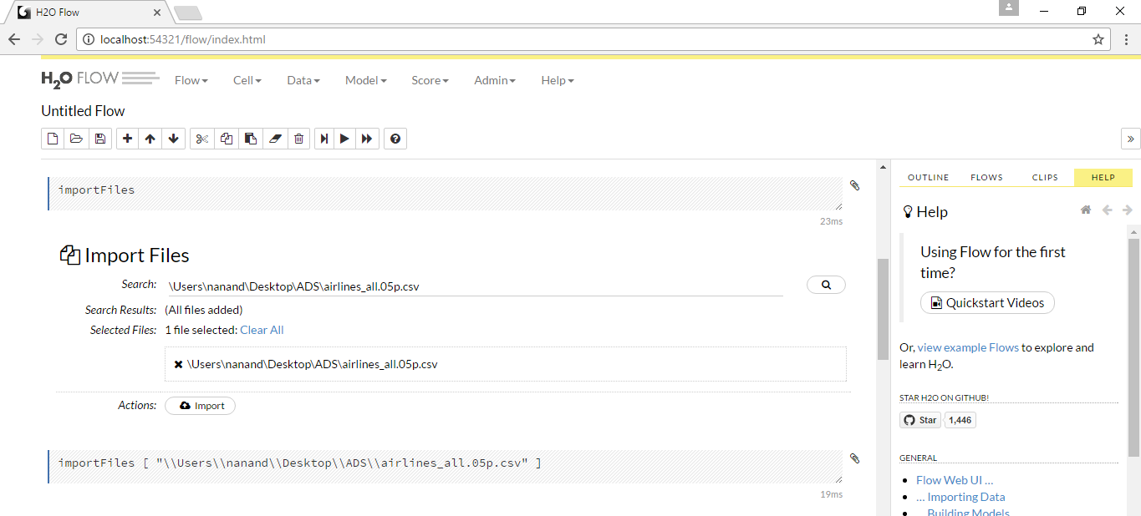

Step 2: Parse the imported files. It might take few seconds.

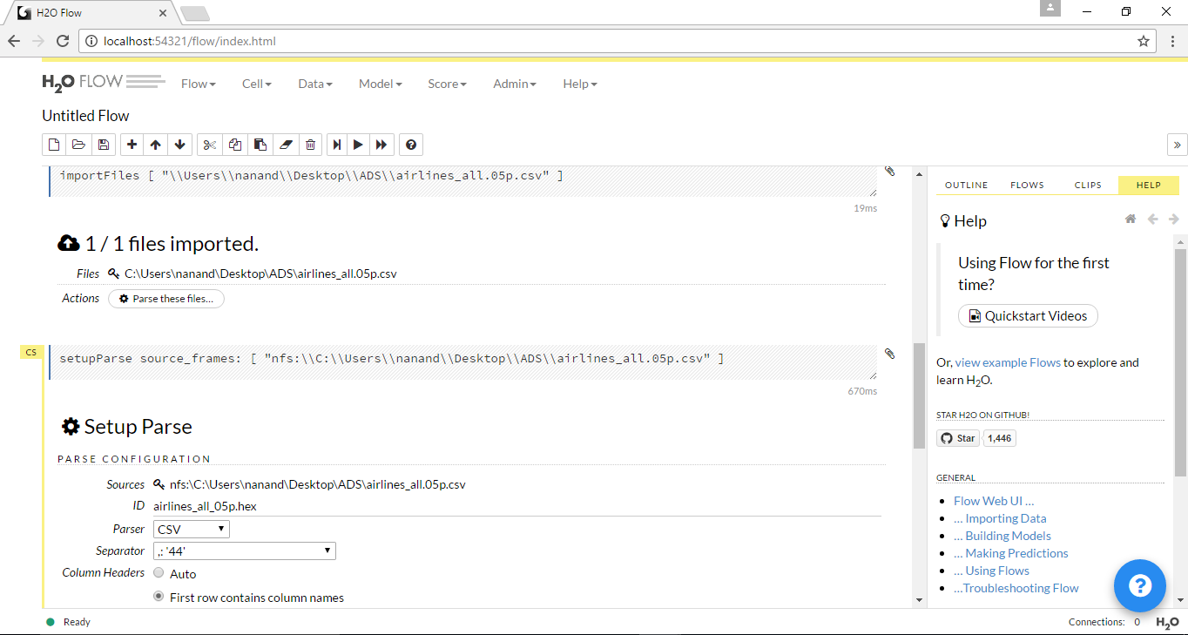

Step 3: Once the file has been parsed, you can select the required data type for each column

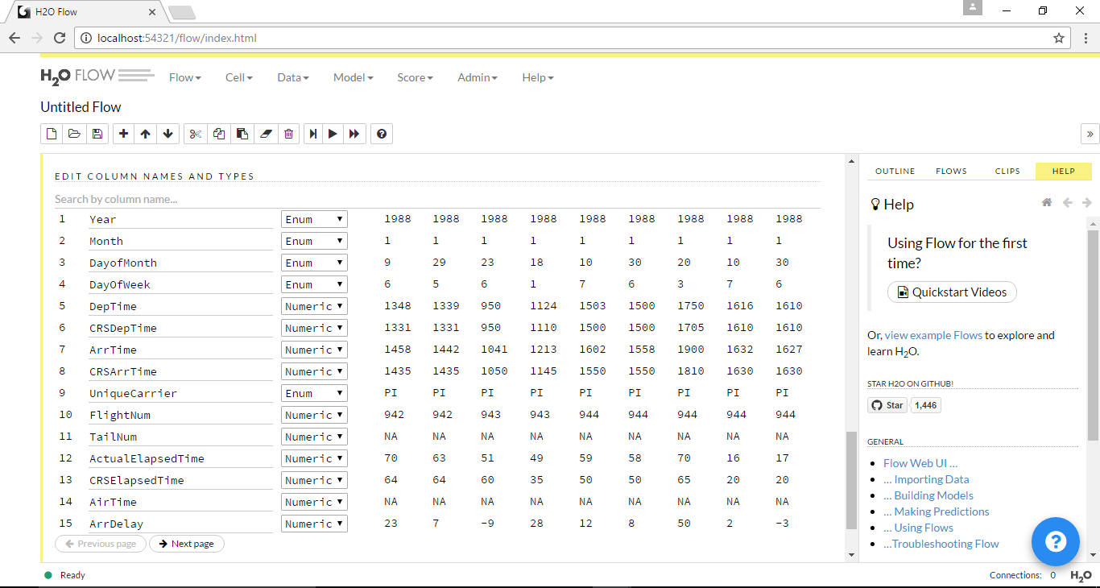

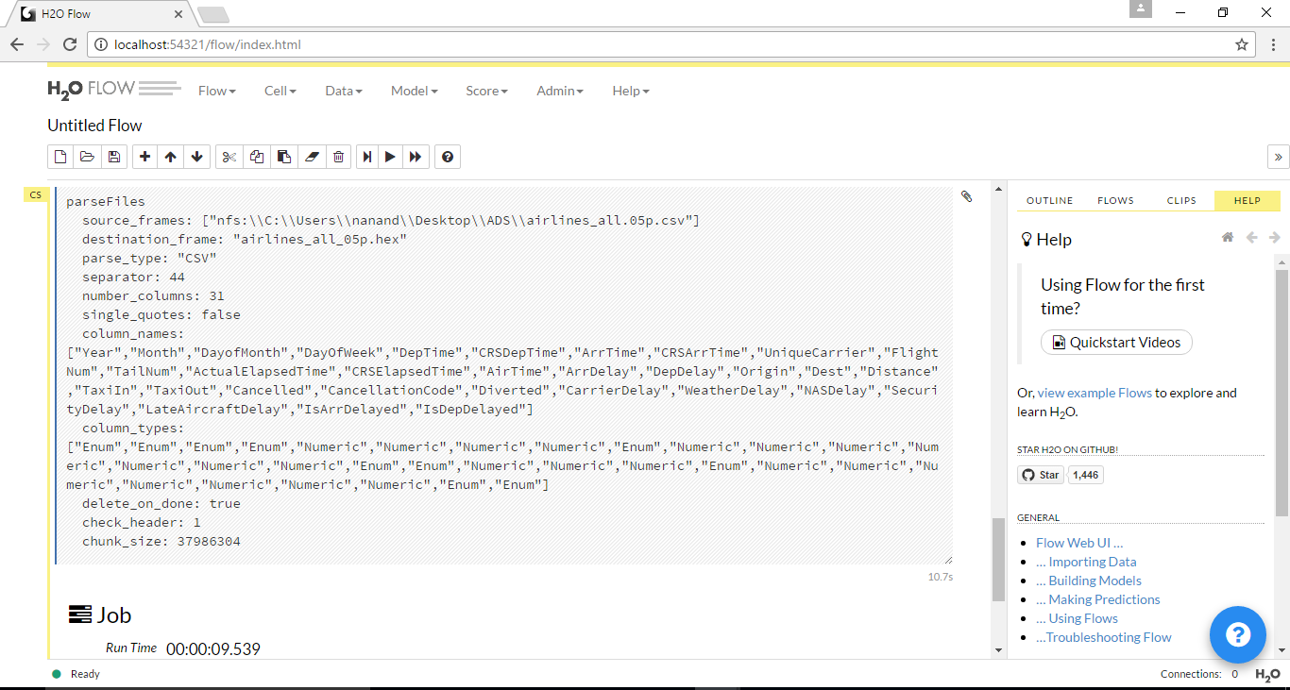

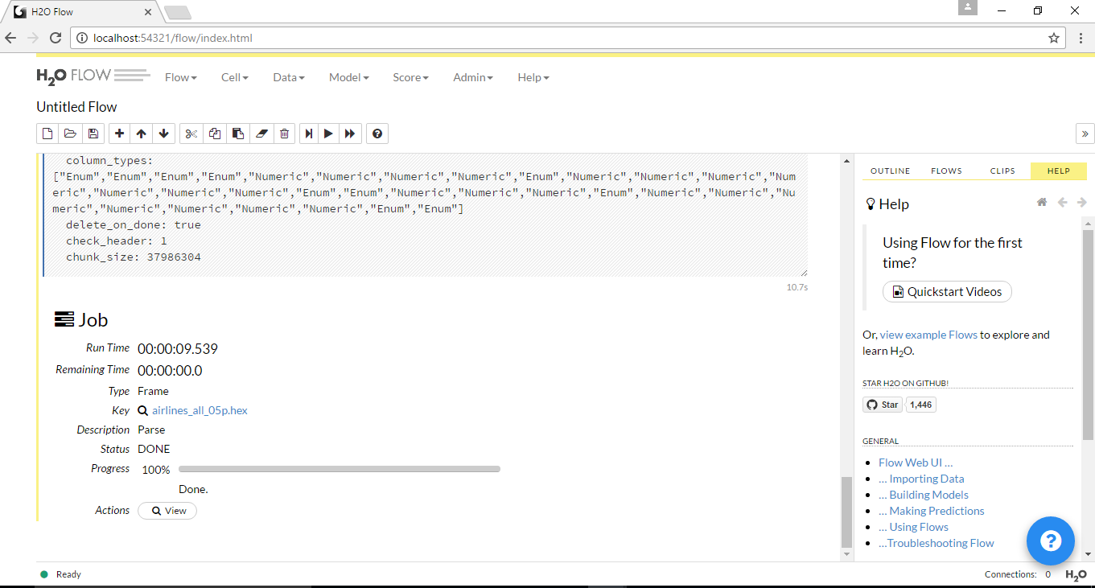

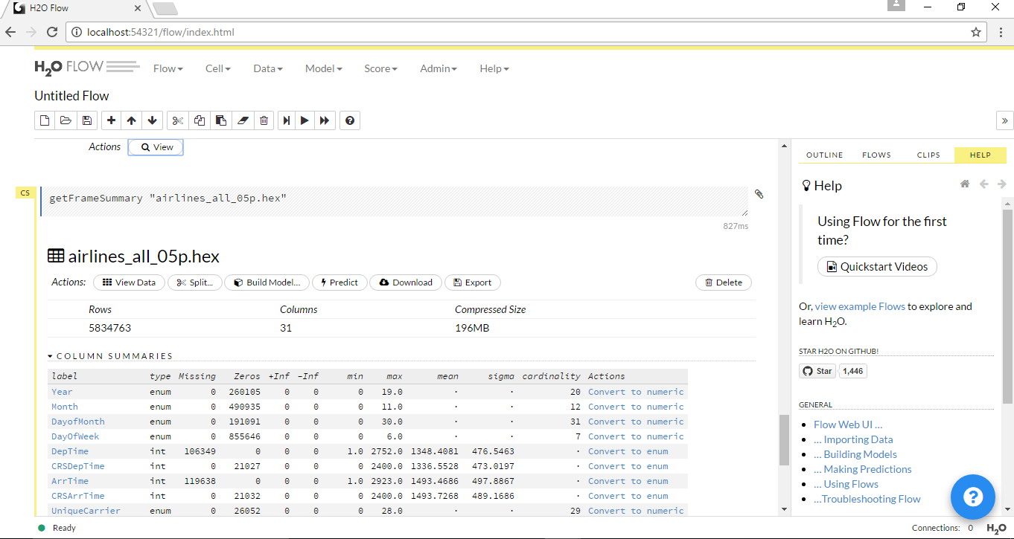

Step 4: View the Frame and split the data sets in to ratio of 75% and 25% for train_data and test_data respectively.

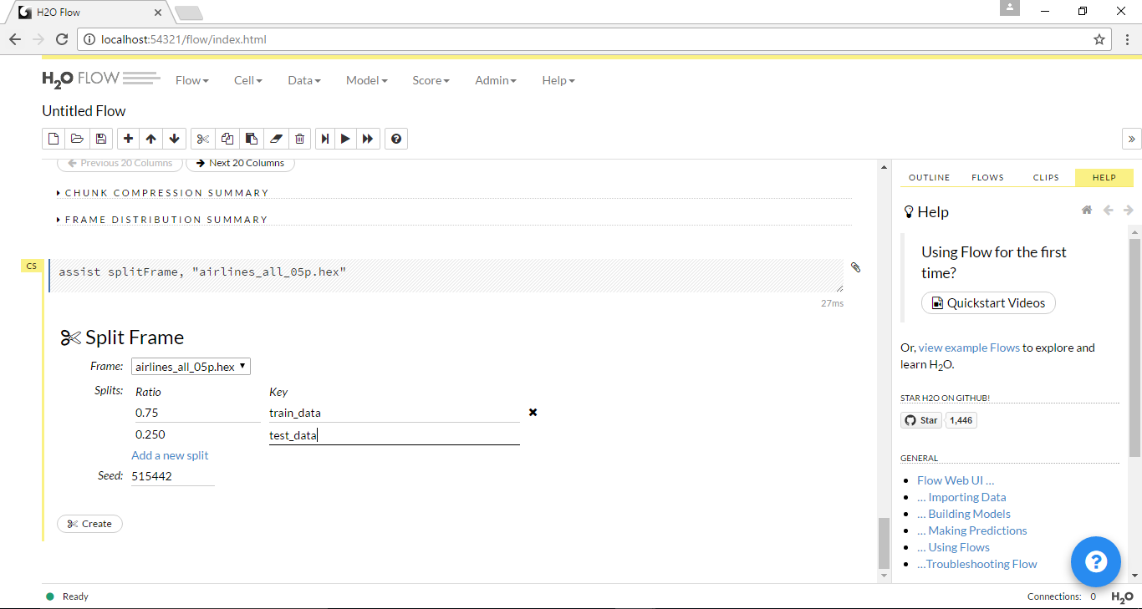

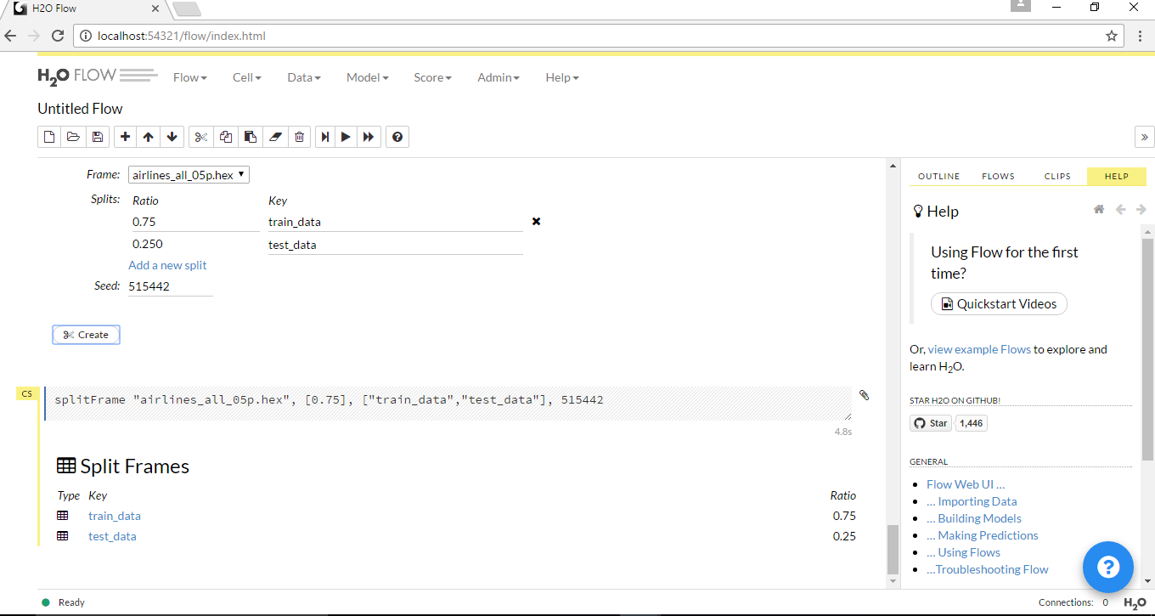

Step 5: Select the prediction model and select the train and test frame for this model. Also set the response column over which you which to do the analysis

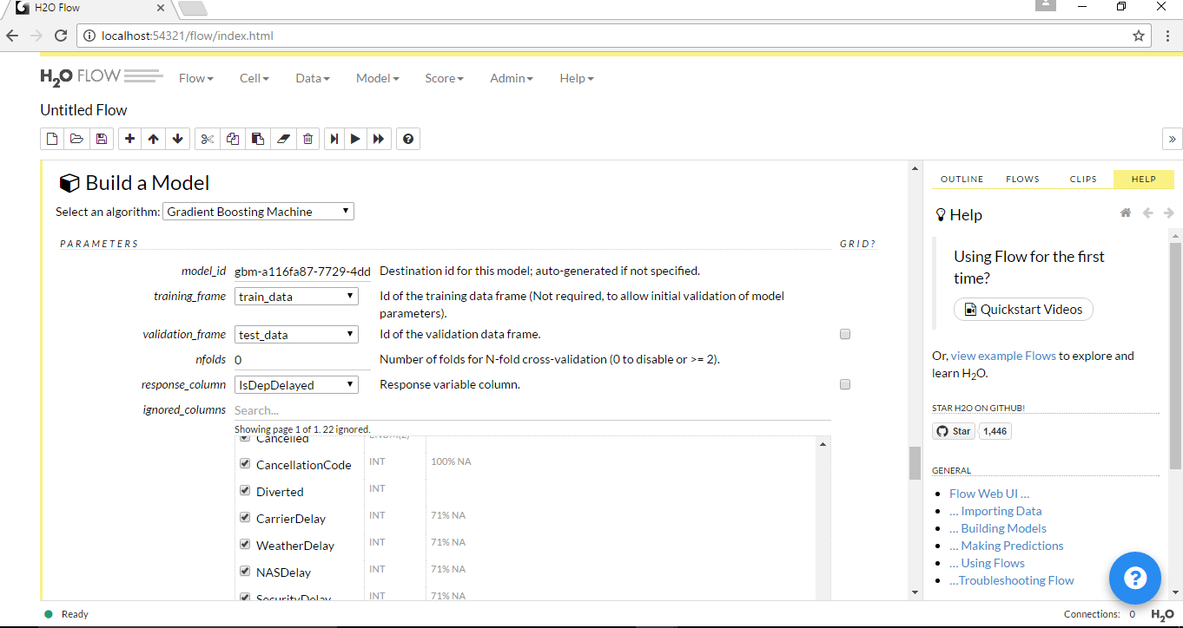

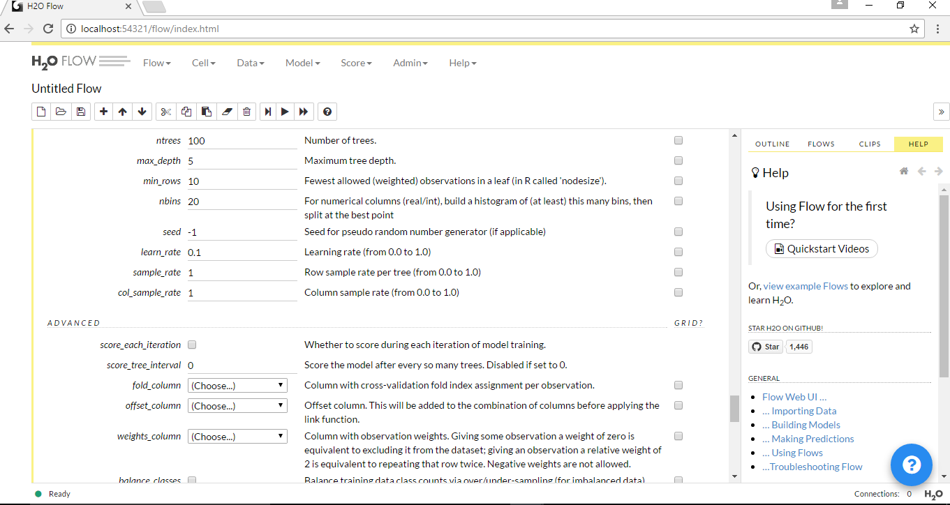

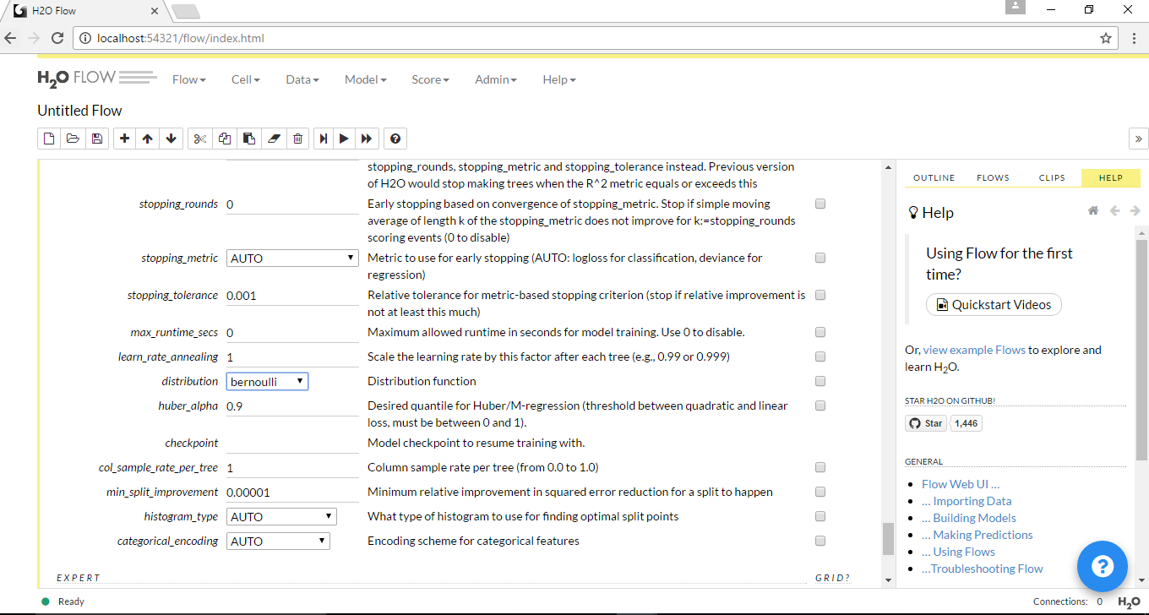

Step 6: Click on Build Model

